Install Power BI Desktop and share the final screenshot of the report view page which appears when power desktop starts.

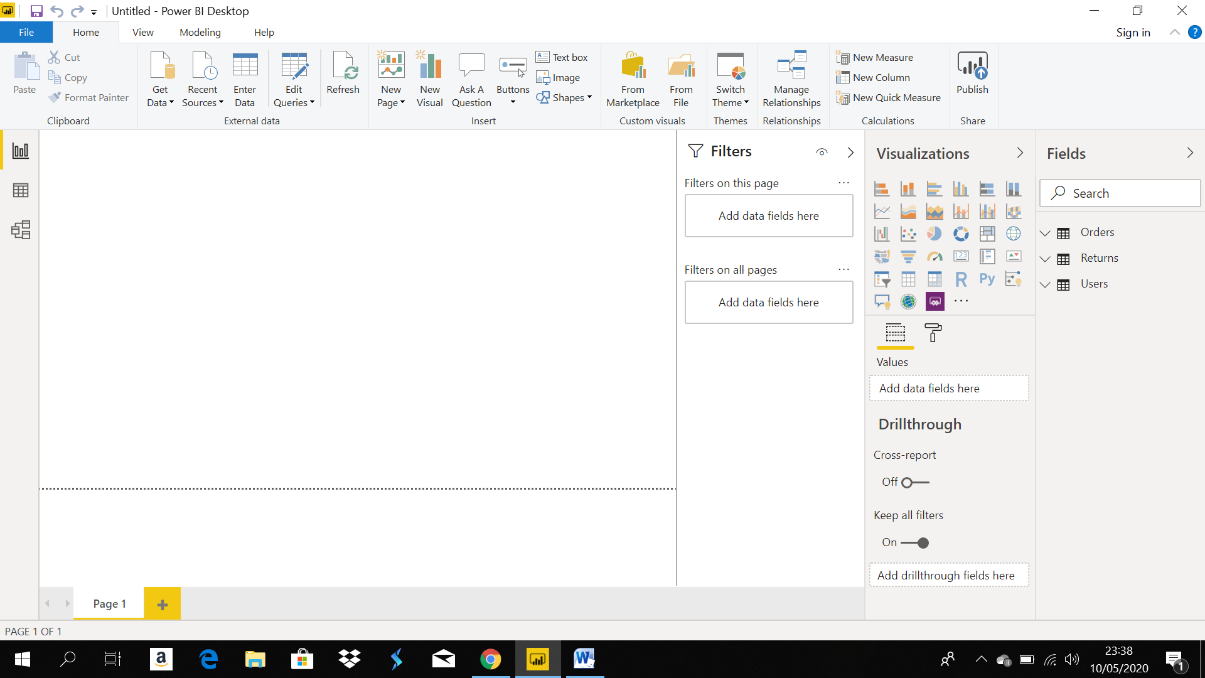

• Prepare a document and with the following screenshot –

Report View – For generating and visualising reports

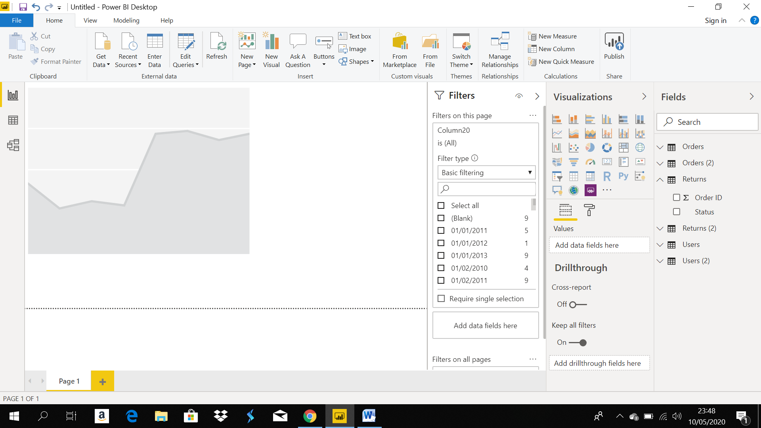

Data View – Once the data is featured you can view the same under data view tab

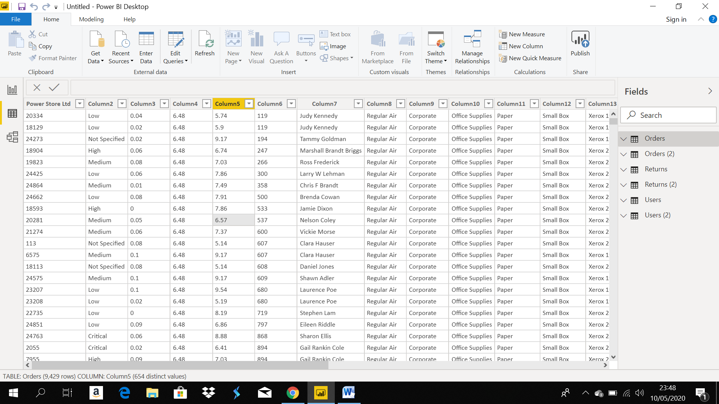

Model View – You may design the model architecture here

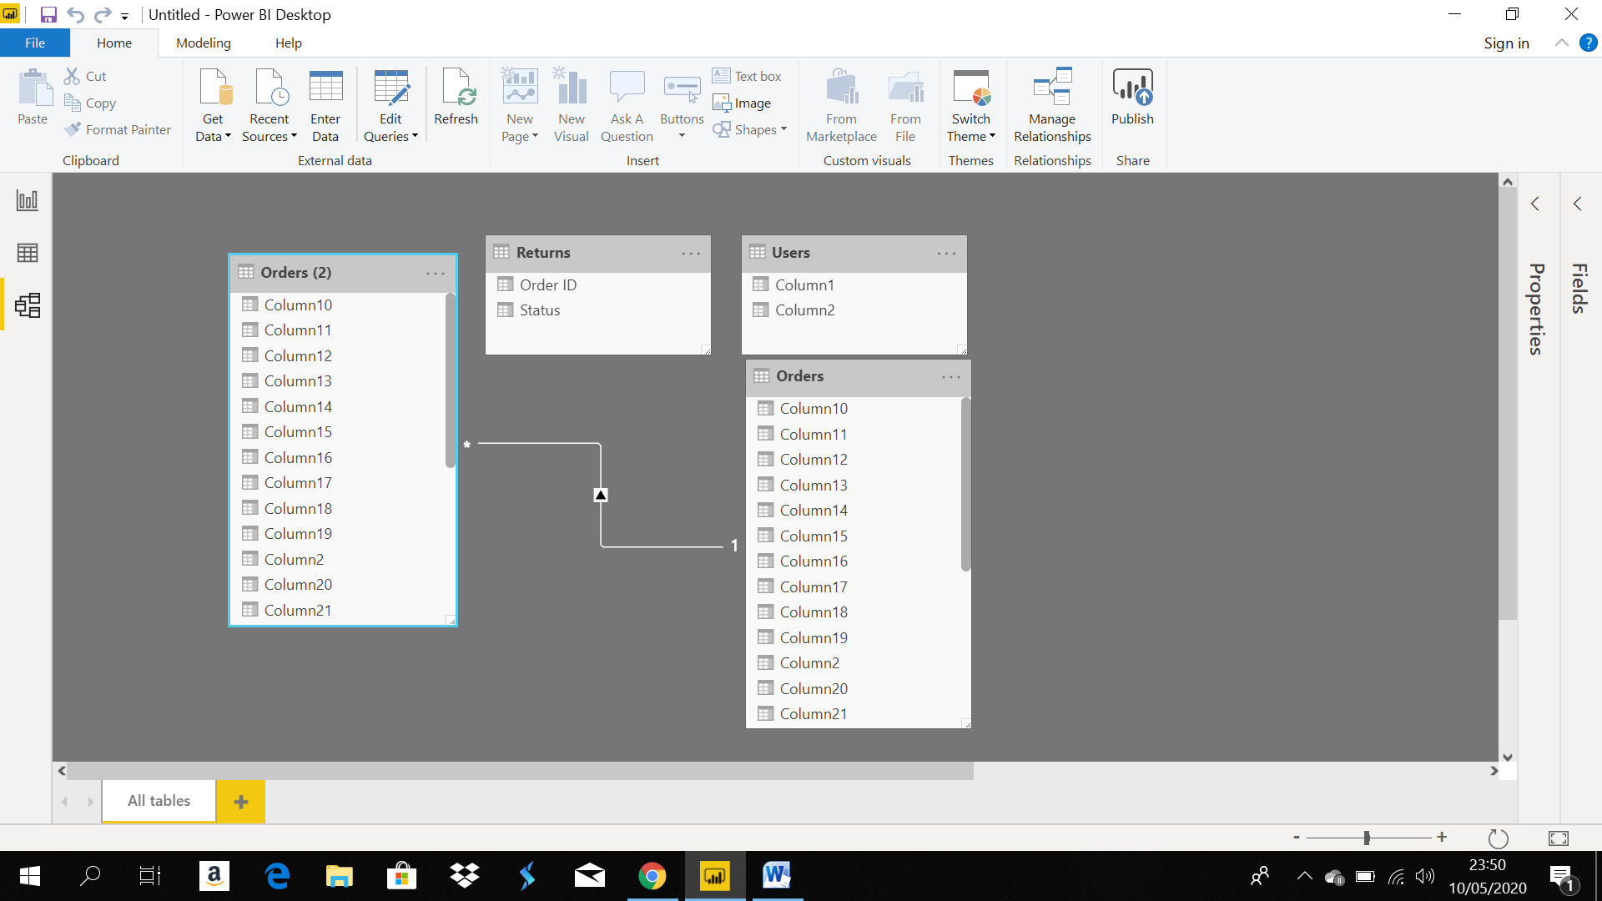

Power Query Editor – Power query editor can be used to transform datas, and do feature engineering

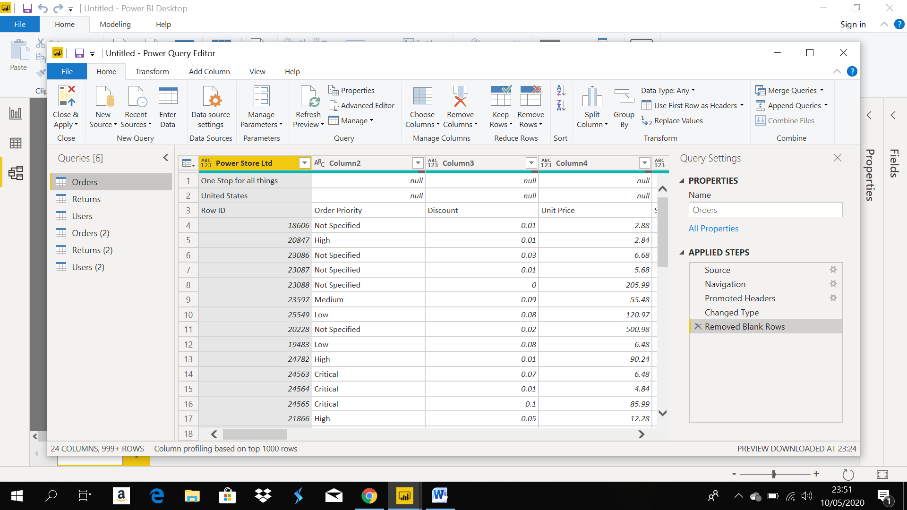

Advance Editor – Various options available to do ETL



Prepare a document with details of the following along with their price –

Power BI Desktop – Free

Power BI Pro – $9.99 per user monthly

Power BI Premium- $4,995 monthly